

***Committed to Excellence***

St. Peter’s College

042 Sabayle St., Iligan City

**COLLEGE OF COMPUTER STUDIES (SEMINAR AND TOURS)**

**NARRATIVE REPORT ON SEMINAR (FREELANCE-ONLINE WORK)**

On the morning of February 3, 2024, at approximately 9:00 am, the 4th-year students gathered in the computer laboratory, Room A203, for a seminar led by Sir Ryan Balisi. As we waited for the rest of our classmates to arrive, we stayed inside the lab. At around 9:30 am, Sir Ryan began the seminar, starting with a prayer led by Kluivert Fritzroy De Asis and an opening by Edward Cabello.

Sir Ryan discussed Freelance-Online Work, sharing his insights and experiences. He provided tips on starting an online career, emphasizing the importance of building a portfolio and showcasing previous work. He also showed us his online profile, including client comments and past projects.

By around 11:00 am, the seminar was winding down. We asked various questions about Freelance-Online Work, particularly about enhancing our skill sets and focusing our efforts. Finally, we took pictures with Sir Ryan as the seminar concluded.

Prepared by:

Edward Jr A. Cabello

       Student

Checked by:

MELLANIE S. GAMBE, MSIT

Dean, College of Computer Studies

Reviewed & Approved by:

MELLANIE S. GAMBE, MSIT

Dean, College of Computer Studies

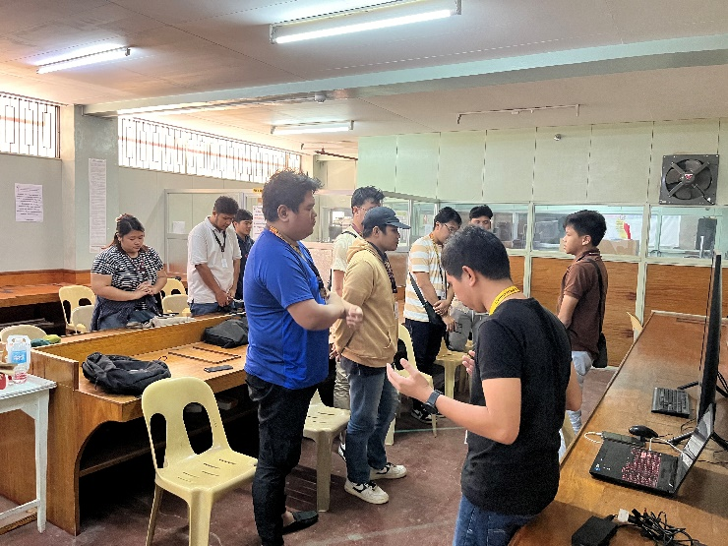  
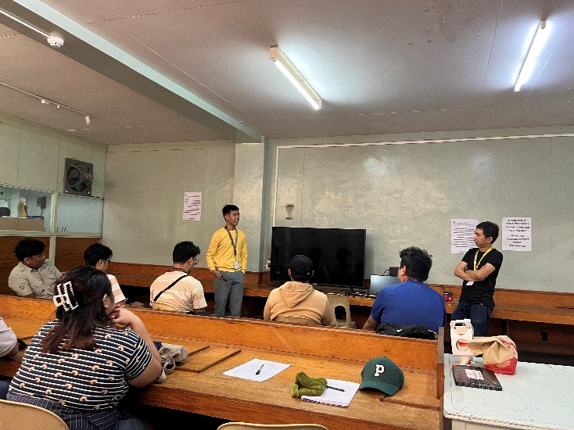

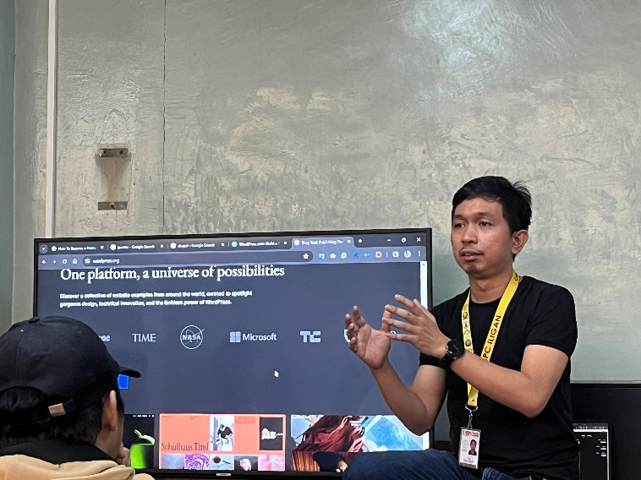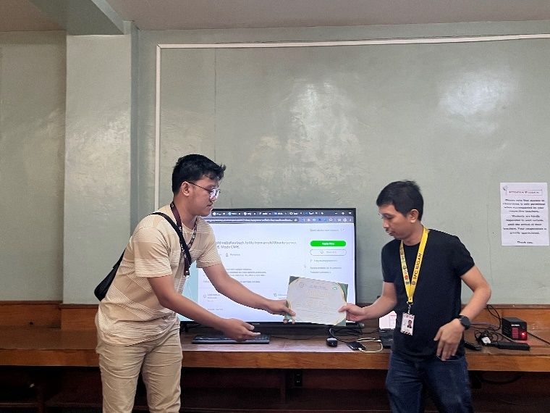

Left: Prayer.

Right: Opening Program.

Bottom-Left: Sir Ryan Discussing about the Seminar is all about

Bottom-Right: Giving the Certificate of Appreciation